Cooking with
Cruisin’ with Kyle


2006

☺
Hi!
My name is Kyle from Cruisin’ With Kyle.
Some of these recipes are what I made in cooking class. Others are made from my Grandma’s cookbook.
I hope you have fun making things!

Love,

☺

On the cover: 2005 – Kyle standing in Lake Michigan on vacation
with his family. This is a touching photo of a very powerful Kyle.
“Kids Kicking Cancer” teaches its students to be "powerful."

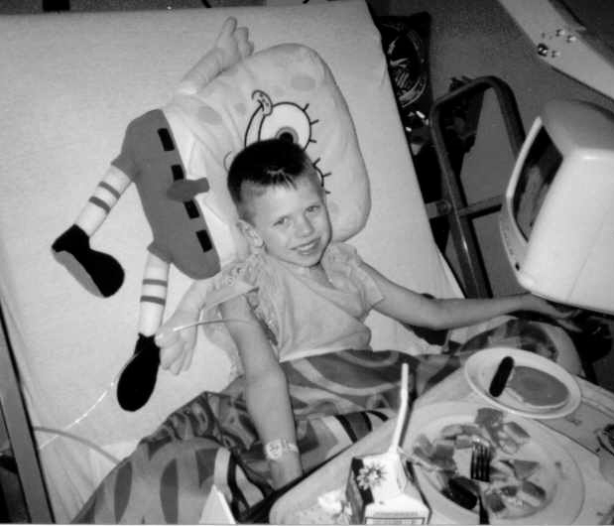

March, 2003 – Kyle post-surgery,
out of PICU, showing incredible courage.

Appetizers,
Dips and Snacks



March, 2003 – Kyle, home from the hospital, with
a new friend alongside him and a card expressing his feelings

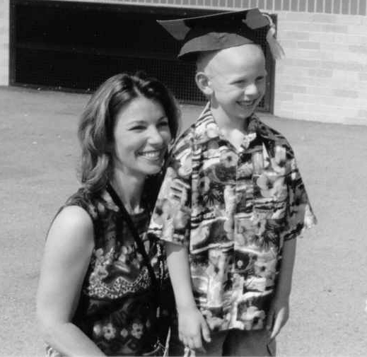

June, 2003 – Kyle at his Kindergarten graduation
with teacher, Mrs. Susan Trebilcock.
Mrs. Trebilcock also home-schooled Kyle
when he was first out of the hospital.

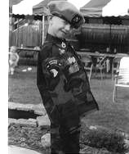

June, 2003 – Kyle wearing his newly acquired
Army Rangers uniform presented to him by the Rangers
along with an award of bravery.

Bread Dip in the Round
From the kitchen of Grandma Lois

⅓ can beer
3 (8 oz.) jars Cheez Whiz
Dash of garlic powder
One loaf round bread

In sauce pan, bring beer to boil, lower heat, add cheese spread and garlic powder. Cook 5 minutes, stirring constantly.
Hollow out loaf of bread and place on platter, with chunks of bread placed around bread loaf. Pour cheese mixture into bread loaf and dip with bread chunks or crackers.

Grandma Denise's Shrimp Dip
From the Kitchen of Grandma Denise

1 (8 oz.) pkg. cream cheese, softened
1 tsp lemon juice

½ tsp. Worcestershire sauce
2 chopped green onions
6 oz. drained, flaked shrimp

Combine all ingredients. Optional - sprinkle with parsley flakes. Serve with Triscuits or other crackers.

Garlic and Feta Cheese Dip
From the kitchen of Mary Condon, family friend

4 oz. feta cheese, crumbled (about 1 cup)
4 oz. fat-free cream cheese, softened
⅓ cup Hellman's Low Fat Mayonnaise
1 garlic clove, minced
¼ tsp. basil
¼ tsp. oregano
⅛ tsp. dill weed
⅛ tsp. thyme

Assorted vegetables and low fat, whole grain crackers
In food processor, combine feta, cream cheese, mayonnaise, garlic, basil, oregano, dill and thyme. Process until thoroughly mixed. Cover and chill until serving time. Serve with vegetable crudités and crackers. Yields 1½ cups.

Chili Cheese Dip
From the kitchen of Aunt Pam

1 pkg. medium cheddar cheese
1 can of chili
1 jar of salsa
1 pkg. Tostitos tortilla chips

In a microwave safe bowl, place package of cheese (break in two pieces) and can of chili. Microwave for approx. 5 – 6 minutes or until cheese melts. Mix together and serve. Top mixture with salsa on chips, if desired.

Sausage Cheese Balls
From the kitchen of cousin Merritt

2 lbs. raw breakfast sausage
1½ cups biscuit mix
4 cups grated sharp cheddar cheese
½ cup finely chopped onion
½ cup finely chopped celery
½ tsp. garlic powder

Preheat oven to 375 degrees F. Mix all ingredients. Form into 1” balls and bake for 15 minutes on ungreased cookie sheet till golden brown. Makes about 6 dozen. Can be frozen uncooked.

Artichoke Dip
From the kitchen of Grandma Lois

2 large cans artichokes, chopped
1½ cup salad dressing
1½ cup parmesan cheese
Pinch of garlic powder
Pinch of oregano
Pinch of basil

Mix together, spread in a glass dish.
Bake at 350 degrees for 20 – 25 minutes.
Sprinkle with parsley. Serve warm.

Dill Dip
From the kitchen of Sarah Umscheid, ACS, Chesterfield Relay Leader

1 cup sour cream
1 cup Real Mayo
1 tsp. Tabasco sauce
½ tsp. Worcestershire
1 heaping tsp. each of parsley flakes, minced onion, dill weed, garlic salt, and Accent

Mix well. Refrigerate at least 2 hours or even better, at least a day.

Peanut Ginger Chicken Lettuce Wraps
From the kitchen of cousin Merritt

1½ or so cups cooked diced chicken breast
¼ cup peanut ginger sauce (any good commercial brand)
2 tbsp. finely chopped onion
2 tbsp. hoisin sauce
1 tbsp. finely chopped fresh cilantro, optional
6 to 8 Boston, bibb or leaf lettuce leaves
1 tbsp. sesame seeds, toasted

Combine chicken, peanut ginger sauce, onion, hoisin and cilantro in microwave-safe bowl; mix well. Microwave, covered, on high until warm, about 1 minute. Arrange lettuce leaves in single layer on platter. Spoon chicken mixture into each lettuce leaf, dividing evenly. Sprinkle with sesame seeds. Fold sides of lettuce leaves over filling and roll up. Makes 6 to 8 wraps.
To toast sesame seeds: Spread seeds in small skillet; cook over medium heat until golden, about 3 minutes, stirring frequently. Remove from skillet immediately to prevent burning.

Kyle's Trail Mix
From the kitchen of Kyle’s mom, Beth

Cheerios
Cheez-Its
Raisins
Sunflower Seeds
Chocolate Chips
Butterscotch Chips

Mix together and enjoy!

Maple Chicken Drummies
From the kitchen of cousin Merritt

¼ cup real maple syrup or honey
¼ cup chili sauce
2 tbsp. chopped fresh chives
1 tbsp. soy sauce
½ tsp. ground mustard
¼ tsp. ground red pepper (cayenne), if desired
2 lb. (about 20) chicken drummettes

Heat oven to 375 F. Mix all ingredients except chicken. Place chicken on ungreased large baking sheet. Pour syrup mixture over chicken; turn chicken to coat.
Bake uncovered 45 to 55 minutes, turning once and brushing with sauce after 30 minutes, until juice of chicken is no longer pink when centers of thickest pieces are cut. Serve chicken with sauce.

Crabmeat and Shrimp Appetizer
From the collection of Uncle Mike Collins

8 −12 oz. cream cheese (softened)
Large bag of frozen shrimp
2 small cans of crabmeat
Dill weed
garlic powder
salt and pepper

For cocktail sauce:

ketchup (20 oz. bottle)
lemons (1 or 2 squeezed)
horseradish (½ bottle or
to taste)

Chop the shrimp and crabmeat into fine pieces and drain well; pat dry on paper towel; then mix together in a bowl. Add dill weed, garlic powder and salt and pepper to taste.
In another bowl mix the ketchup, horseradish and lemon juice.
Shape the cream cheese into the shape of a disk and place in the center of a large plate. Totally cover the cream cheese mound with the shrimp and crabmeat mixture.
Pour the cocktail sauce over the mound.
Serve with hearty wheat crackers.

Soups, Salads
and Sandwiches

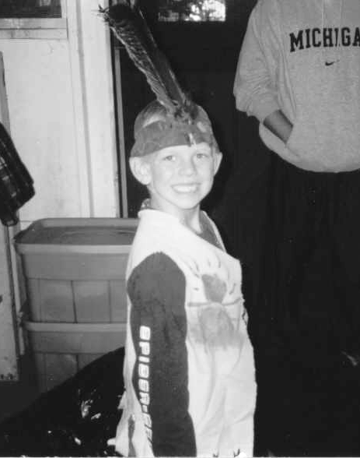

August, 2003 – Kyle's 1st year at Camp Quality

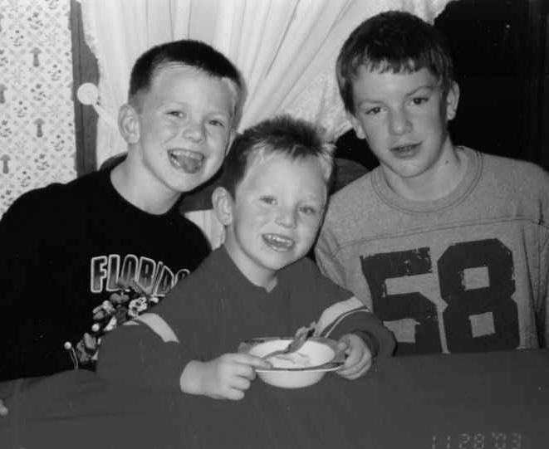

November, 2003 – Thanksgiving at Grandma and Grandpa's: Kyle, Bryan and cousin Nick

Winter Squash Soup w/Gruyère Croutons
From the kitchen of cousin Merritt
Soup

¼ cup (½ stick) butter
1 large onion, finely chopped
4 large garlic cloves, chopped
3 (14½ oz.) cans low-salt chicken broth
4 cups 1-inch pieces peeled butternut squash (about 1½ lbs.)
4 cups 1-inch pieces peeled acorn squash (about 1½ lbs.)
1¼ tsp. minced fresh thyme
1¼ tsp. minced fresh sage
¼ cup whipping cream (or soy coffee cream)
2 tsp. sugar

Croutons

2 tbsp. (¼ stick) butter
24 ¼-inch thick baguette bread slices

1 cup grated Gruyère cheese
1 tsp. minced fresh thyme
1 tsp. minced fresh sage

For soup:
Melt butter in large pot over medium heat. Add onion and garlic and sauté until tender, about 10 minutes. Add broth, all squash and herbs; bring to boil. Reduce heat, cover and simmer until squash is very tender, about 20 minutes.
Working in batches, puree soup in blender, or use an immersion blender. Return soup to same pot. Stir in cream and sugar; bring to simmer. Season with salt and pepper. (Can be made 1 day ahead. Chill. Re-warm over medium heat before serving.)
For croutons:
Preheat broiler. Butter 1 side of each bread slice. Arrange bread, buttered side up, on baking sheet. Broil until golden, about 1 minute. Turn over. Sprinkle cheese, then thyme and sage over. Sprinkle with salt and pepper. Broil until cheese melts, about 1 minute. Ladle soup into bowls. Top each with croutons and serve.
Serves 8.

Lentil, Vegetable and Barley Soup
From the kitchen of cousin Merritt

1 tsp. olive oil
3 – 4 cloves of garlic, crushed
1 cup diced onion
½ cup celery, chopped finely
1 cup carrots, peeled & diced
6½ cups of water
1 cup red lentils
¼ cup barley (not the quick-cooking kind)
1 tbsp. dried basil
½ tsp. salt
Black pepper to taste
2 bay leaves
2 bouillon cubes (vegetable, chicken or beef)

Heat the olive oil in a large soup pan over medium heat. Add the garlic, onions, celery and carrots. Cook the vegetables about 5 minutes, stirring constantly.
Add remaining ingredients to saucepan, bring mixture to a boil, reduce heat to medium-low, cover, and either cook for one hour; or transfer it all to a crock-pot and cook on low all day.
Remove and discard the bay leaves before serving.

Broccoli Salad
From the kitchen of Grandma Lois
Dressing:

1 cup salad dressing
2 tbsp. sugar
2 tbsp. white vinegar

Mix together:

6 cups broccoli florets
3 cups cauliflower florets
1 cup chopped carrots

1½ cups bacon bits
1½ cups sliced red onion
1 cup mozzarella cheese, shredded

Mix together and add dressing.

Great Grandma Brady's Beer Bread
From the Kitchen of Great Grandma Brady

1 can beer or 7 oz. cup
3 cups self rising flour
⅓ cup sugar

Mix all ingredients together. Batter will be lumpy. Place in greased bread pan and bake at 350 for 1 hour. This goes great with soups and salads.

French Onion Soup
From the kitchen of Sarah Umscheid, ACS, Chesterfield Relay Leader

¼ cup butter
3 medium white onions, sliced
4 (14 oz.) cans beef broth
1 tsp. salt
¼ tsp. garlic powder
3 tbsp. grated parmesan cheese
6 to 12 slices French bread
6 slices Swiss cheese
6 slices mozzarella cheese
6 tbsp. shredded parmesan cheese

Sauté onions in melted butter in a large soup pot for 15 to 20 minutes until onions begin to brown and turn transparent.
Add broth, salt and garlic powder to onions. Bring mixture to a boil, then reduce heat and simmer uncovered for 1 hour. Add the grated parmesan cheese in the last 10 minutes.
When soup is done, preheat oven to 350 degrees and toast the French bread slices for about 10 to 12 minutes or until they begin to brown. When bread is done, set oven to broil.
Build each serving of soup by spooning about 1 cup into an oven-safe bowl. Float a toasted slice or two of bread on top of the soup, then add a slice of Swiss cheese on top of that. Place a slice of mozzarella on next and sprinkle 1 tbsp. of shredded parmesan cheese over the top of the other cheeses.
Place the soup bowl on a baking sheet and broil for 5 to 6 minutes until the cheese begins to brown.

Pasta Salad
From the kitchen of Grandma Lois

1 lb. cooked rotini noodles
1 chopped onion
2 tomatoes, chopped
1 (16 oz.) bottle Italian dressing
2 peppers, chopped (red and green)
½ bottle McCormick’s salad supreme seasoning

Mix all ingredients and refrigerate overnight.
Note: add ½ cup grated parmesan cheese.

Caramel Apple Salad
From the kitchen of cousin Merritt

1 small can crushed pineapple, undrained
4 unpeeled apples, chopped (red delicious/granny smith make a good combination)
1 small box instant butterscotch pudding (regular or fat-free)
1 (8 oz.) tub cool whip (regular or fat-free)

Mix pudding and cool whip thoroughly. Add pineapple, mix well. Fold in apples, chill, and let set at least an hour.
Alternately, use vanilla pudding; 2 tsp. maple flavoring and 1 tsp. cinnamon instead of butterscotch pudding.

Potato Salad
From the kitchen of Grandma Lois

8 – 10 potatoes; boiled, cut in small wedges
5 boiled eggs, chopped
1 medium onion chopped
2 stalks chopped celery
1 cup salad dressing (light Miracle Whip)
Salt and pepper to taste

Mix all together and refrigerate.
Sprinkle with paprika.

Napa Cabbage Salad
From the kitchen of Debby Hunter, family friend

Dressing:

1 cup sugar
1 cup oil
½ cup apple cider vinegar
3 tbsp. soy sauce

Salad:

1 large (or 2 med/small) Napa cabbage heads (Chinese cabbage)
5 – 6 green onions

1 package of ramen noodles
½ cup sesame seeds
½ cup sliced almonds
2 tbsp. butter or margarine

Combine dressing ingredients in small bowl until sugar dissolves.

Sauté the sesame seeds and almonds in the butter. Let cool.
Shred/cut the cabbage. Use only the dry noodles and crumble/crunch into the salad (discard the seasoning packet). Add almonds/seeds when cool and toss. Toss salad with desired amount of dressing.

BBQ Beef Sandwiches
From the kitchen of cousin Merritt

2½ lb. (or thereabouts) lean boneless chuck roast
¼ cup tomato ketchup
1 tbsp. Dijon-style mustard
2 tbsp. brown sugar
1 garlic clove, crushed
1 tbsp. Worcestershire sauce
2 tbsp. red wine vinegar
¼ tsp. liquid smoke flavoring
¼ tsp. salt
⅛ tsp. pepper
10 French rolls or sandwich buns -- (10 to 12)

Place beef in slow cooker. Combine remaining ingredients, except rolls. Pour over meat. Cover and cook on low 8 to 9 hours. Shred beef by pulling it apart with 2 forks. Add one cup sauce. Reheat mixture in microwave or on stovetop.
Spoon on warm, open-face rolls or buns. Top with additional warm sauce if desired.

Low Fat Asian-Style Slaw
From the kitchen of cousin Merritt
Dressing:

2 tbsp. tahini or peanut butter
2 tbsp. rice wine vinegar
2 tbsp. soy sauce
2 tbsp. brown sugar
2 tbsp. freshly grated ginger
2 tsp. minced jalapeno (or more or less, to taste – red pepper flakes work, too)

Salad:

1 head thinly sliced napa cabbage or bag of grated coleslaw
1 cucumber, peeled, seeded and thinly sliced
1 – 1½ cups grated carrot

In a large salad bowl, whisk the soy, vinegar, tahini or PB, brown sugar, ginger and hot pepper. Stir until combined.
Add cabbage, cucumber, and carrots, toss until well coated, and serve. It’s even better topped with chopped grilled chicken.

Strawberry Pretzel Salad
From the Royal Oak Woman’s Club kitchen

¾ cup margarine, melted
3 tablespoons brown sugar
2¼ cups crushed pretzels
1 large package strawberry gelatin
2 cup boiling water
3 cups cold strawberries
1 (8 oz.) package cream cheese
¾ cup brown sugar
1 carton frozen whipped topping (thawed)

Mix the margarine, brown sugar and pretzels together, and then press into a 9 x13 backing dish. Bake for 10 minutes at 350 F.
Dissolve the gelatin in 2 cups of boiling water, stir in the strawberries. Chill just until it begins to set.
Blend together cream cheese and sugar, fold in whipped topping. Spread on cooled crust. Pour strawberry mixture over cheese blend. Chill.
All three of these can be made in stages, as time allows.

Vinaigrette
From the kitchen of Sandy Petropoulos, family friend

½ tsp. kosher salt
1 tsp. Dijon mustard
¼ cup white wine or red wine vinegar
¾ cup olive oil

Combine mustard, salt and vinegar in 1 cup container and whisk with fork till salt is dissolved - add oil in a stream, whisking. Refrigerate for one month before serving. Makes one cup.

Salad with Spicy Peanut Sauce
From the kitchen of cousin Merritt
Dressing:

1 tbsp. sesame oil
3 tbsp. rice wine vinegar
¼ cup light soy sauce
2 tbsp. sugar
1 tbsp. freshly grated ginger
½ tsp. red pepper flakes (or more or less, to taste)

Salad:

8 cups thinly sliced napa cabbage
1 cup loosely packed, roughly chopped cilantro leaves
3 scallions, thinly sliced
1 medium carrot, grated
1 cup toasted (or not) peanuts, roughly chopped

Whisk dressing in a small non-reactive bowl until sugar dissolves.
In a large salad bowl, toss together the salad. Add peanuts. Add dressing and toss until evenly distributed. Taste and adjust seasonings. Serve immediately.
Also excellent with a modest amount of chopped grilled chicken.
Peanuts can be toasted in a nonstick pan over medium-high heat, tossing often, until fragrant and crunchy, 3 to 5 minutes.

Oriental Cole Slaw
From the Kitchen of Aunt Suzanne

Salad:

1 lb. pkg. cabbage slaw blend
4 green onions, chopped
1 (3 oz). chicken ramen noodle soup mix
½ cup toasted slivered almonds
3 tbsp. toasted sesame seeds (optional)

Break ramen noodles into small pieces. Combine with cabbage and onions. Carefully toast almonds on stove top and add to mixture. Toast sesame seeds and add, if desired.
Dressing;

½ cup vegetable oil
3 tbsp. white vinegar
3 tbsp. sugar
1 flavor pack from soup mix

Mix dressing ingredients well and add to salad just prior to serving. Serves 10.

Tuna Pasta Salad
From the kitchen of Aunt Pam

2 cans of tuna (in water), drained
1 lb. of farfalle pasta (bowtie)
2 cups Miracle Whip Light
Salt to taste

Note: chopped onion is an option.
Cook pasta, drain under cool running water. In a large bowl, add pasta, tuna, Miracle Whip and salt. Mix together.

Breakfasts
and Brunches

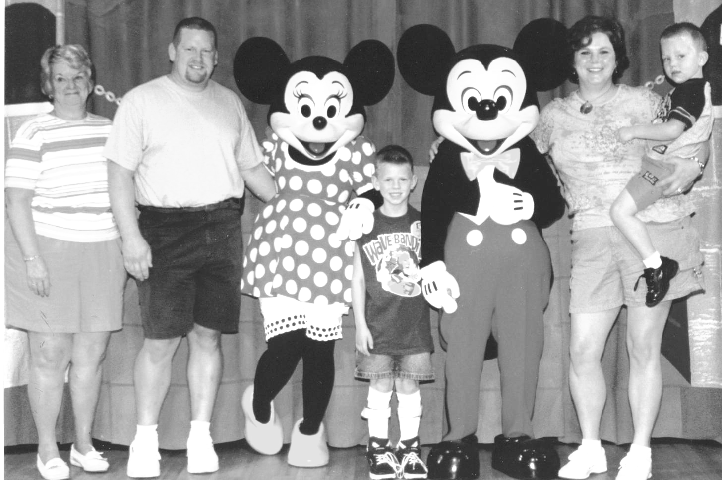

October, 2003 – Kyle's Make-A-Wish Trip
to Walt Disney World, Florida!



October, 2003 – Kyle on his Make-A-Wish Trip to Walt
Disney World, with little brother, Bryan

Breakfast Burritos
From the kitchen of Aunt Pam

Large soft tortillas
Eggs
Medium cheddar cheese
Bacon bits
Salt and pepper to taste

Scramble eggs, salt and pepper to taste.
Place a portion of scrambled eggs on tortilla, adding slice of cheddar cheese on top, with sprinkle of bacon bits. Roll together. Microwave for 25 – 30 seconds for cheese to melt.
Add mild Ortega taco sauce if desired.

Fruit & Nut Breakfast Bites
From the kitchen of cousin Merritt

⅓ cup reduced-calorie soft margarine
⅓ cup sugar
¼ cup honey
½ tsp. ground cinnamon

1¼ cup dried mixed fruit
1¾ cup coarsely crushed
oat flakes
1 cup quick-cooking oats
¼ cup chopped walnuts or sunflower seeds (optional)

Combine margarine, sugar and honey. Cook over medium heat, stirring constantly, until mixture comes to a boil. Boil 1 minute.
Remove from heat; stir in remaining ingredients.
Press mixture into bottom of a 9-inch square baking pan sprayed with cooking spray.
Cool. Cut into pieces and store in a covered container in refrigerator.

Pancakes
From Kyle

1 cup pancake mix
¾ cup milk
1 tbsp. oil
1 egg

Heat skillet over med-high. Grease lightly with oil. Combine pancake mix, oil, milk and egg in a bowl. Stir until large lumps disappear. Pour slightly less than ¼ cup batter for each pancake onto hot skillet/griddle. Cook 1 to 1½ minutes on each side or until golden brown.
Makes 9 – 11 pancakes.

Ziploc Omelets
From the kitchen of cousin Merritt
Great for when all your family gathers on a special occasion or the morning after a slumber party. Nobody has to wait for an omelet.
Set out a variety of diced ingredients such as cheeses, ham, onion, chopped green pepper, olives, mushrooms, sausage, tomato, hash browns, salsa, etc.
Have guests write their names on a quart-size Ziploc freezer bag with permanent marker. Crack 2 eggs into each bag (not more than 2 eggs) and shake to combine and lightly scramble. Or use or ½ cup egg substitute.
Each guest adds prepared ingredients of choice to his/her bag and shakes it.
Make sure to squeeze all of the air out of the bag and zip it up. Place the bags into rolling, boiling water for exactly 13 minutes. You can usually cook 6 – 8 omelets in a large pot. For more, make another pot of boiling water.
Open the bags and the omelet will slide out easily. Be prepared for everyone to be amazed!
Nice to serve with fresh fruit and coffee cake; everyone gets involved in the process and it's a great conversation piece.

Cinnamon Muffins
From the kitchen of Grandma Connie
Mix together:

3 cups flour
3½ tsp. making powder
¼ tsp. salt
½ cup sugar

Beat together:

⅔ cup milk
2 beaten eggs
½ cup canola oil

Mix with flour mixture, put in refrigerator and chill for a least an hour. Roll out on floured board.
Then mix together:

½ cup sugar
1 tsp. cinnamon
½ cup melted oleo

Spread over dough and roll up, cut 1 ½" thick. Place in greased muffin pan. Bake at 375 degrees for 12 – 20 minutes.

German Puffed Pancake
From the kitchen of cousin Merritt

3 eggs, room temperature
½ cup sifted flour
½ tsp. salt
2 tbsp. butter, melted
½ cup milk, room temperature
lemon wedges
powdered sugar

Preheat oven to 450 degrees F. Beat eggs in large bowl. Sift flour and salt into eggs in 4 batches, blending after each addition until smooth. Add milk in 2 batches, blend well after each. Stir in butter.
Generously butter a 9 or 10 inch glass pie plate. Pour in batter. Bake at 450 degrees F for 20 minutes. Reduce temperature to 350 degrees F and continue cooking 10 more minutes. Do not open oven between temperature changes.
Slice and serve immediately with powdered sugar and lemon wedges.

Granola
From the kitchen of cousin Merritt

1 to 1¼ cups brown sugar
½ cup water
4 tsp. pure vanilla extract
1 tsp. salt
8 cups rolled oats
2 cup chopped pecans or walnuts, or slivered almonds (I use raw sunflower seeds)
Dried fruit to taste (I like dried apples & cranberries; apples & cherries; blueberries & cherries)

Preheat oven to 275 degrees F.
Line 2 cookie sheets with parchment paper and reserve.
Combine brown sugar and water in a 4-cup microwave proof glass measuring cup or bowl. Place in microwave on high for 5 minutes and cook until sugar is completely dissolved. Remove from microwave, add vanilla extract and salt.
In a large mixing bowl, combine oats, nuts, and brown sugar syrup mixture. Stir until thoroughly mixed. Spread the granola onto cookie sheets and bake 45 minutes to 1 hour or until golden and crunchy.
When the mixture comes out of the oven, it is still very pliable. You may choose to add in dried fruit as a finishing touch at this time. When granola has cooled completely, store in an airtight container.
Using 1 cup sugar is enough to sweeten the granola. It might even be more than you need, depending on your own taste.
Be creative. Add flaked coconut when you add fruit; add a hint of cinnamon to the sugar...try dates, apricots, sprinkle on some wheat germ...

Sour Cream(less) Coffee Cake
From the kitchen of Aunt Laura

½ cup butter, room temperature, plus ½ tsp. for buttering the pan, divided
1 cup sugar
2 eggs, beaten
1 tsp. baking powder
1 tsp. baking soda
1 tsp. salt
1 cup plain yogurt
1 tsp. vanilla
Topping:
⅓ cup brown sugar
¾ cup white sugar
1 tsp. cinnamon
1 cup finely chopped nuts

Preheat oven to 325 degrees. Cream the ½ cup of butter. Add sugar gradually, creaming well, until light and fluffy. Beat in eggs. Sift flour, baking powder, baking soda, and salt together, then add, alternating with yogurt and vanilla, to butter mixture. Mix well.
Combine topping ingredients and set aside. Pour half of the batter into buttered 9 x 9 x 2 inch pan. Put half of the topping over batter. Pour remaining batter into pan and cover with remaining topping. Bake for 45 minutes. Serves 12.

Quiche
From the kitchen of Aunt Laura
On bottom of pie crust:

10 slices bacon (crispy fried and crumbled)
⅓ cup finely chopped onion
4 oz. grated Swiss or cheddar cheese

Combine in mixing bowl and pour into pie crust:

4 eggs slightly beaten
2 cups whipping cream or half-and-half

½ tsp. salt
⅛ tsp. cayenne pepper
¼ tsp. sugar

Bake at 425 degrees F for 15 minutes, then turn oven down to 300 degrees and bake for 30 minutes.
Substitutions:
Crabmeat for bacon, or ½ cup broccoli for onion.

Overnight “Christmas” Breakfast Casserole
From the kitchen of cousin Merritt

1 large onion, chopped
½ cup diced green bell pepper
½ cup diced red bell pepper
6 slices loaf bread, cubed,
can be stale
6 eggs
1½ cups low-fat milk
1 cup shredded cheddar cheese
salt and pepper to taste
1 lb. sage breakfast sausage (optional; it’s good with or without.)

If using sausage, crumble in a nonstick skilled and brown over med. high heat, stirring occasionally. Add onions and peppers as you chop them. Cook until lightly browned; drain all grease. If not using sausage, cook onions and peppers in a little olive oil.
Slice bread into cubes. Spray an 11 x 7 x 2 inch casserole or baking dish with cooking spray and fill with bread cubes. Sprinkle onions and peppers (with or without sausage) over bread. Whisk together the eggs and milk. Pour over everything else, pressing down until bread is moistened. Sprinkle cheese on top. Cover with foil or plastic wrap and refrigerate overnight.
The next morning, preheat oven to 375 degrees. Bake uncovered, 40 – 45 minutes, or until browned and puffy. Let stand 10 minutes. Cut into squares to serve. Peppers will look festive.

Craig's French Toast
From the kitchen of Kyle’s dad, Craig

3 eggs, beaten
¼ cup milk
½ teaspoon vanilla, optional
½ teaspoon cinnamon
10 slices bread

In a large bowl, mix beaten eggs with the milk, vanilla and cinnamon. Dip a slice of bread into mixture then place on a heated griddle that has been sprayed with nonstick cooking spray. Cook for 1 to 2 minutes on each side on medium / medium-high heat or until desired doneness.
Serves 4.

Main Dishes

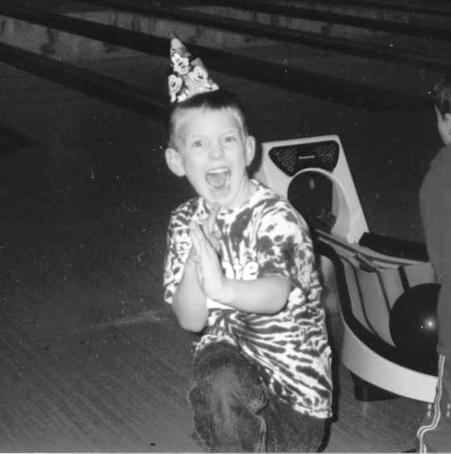

January, 2004 – Kyle hamming it up
at his bowling birthday party.

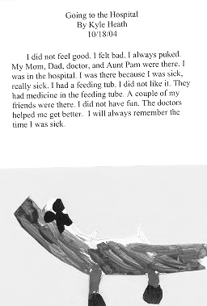

October, 2004 – Kyle wrote this story
about when he was sick and in the hospital.

Spaghetti Sauce
From the kitchen of Grandma Lois

3 lbs. ground beef
1 medium onion
4 cloves garlic
2 large cans tomato sauce
1 small can tomato paste
1 small can mushrooms
¼ cup oregano
A few bay leaves
½ cup Romano cheese, grated

Brown ground beef with onions and garlic.
Drain off fat, add all other ingredients and simmer for about 3 hours.

Shrimp Scampi
From the kitchen of Aunt Cathy

2 tbsp. sliced green onions
1½ tbsp. fresh lemon juice
¼ tsp. salt
2 large cloves of garlic, minced
⅓ cup melted butter
¾ pound peeled de-veined, uncooked shrimp (frozen is fine)
2 tbsp. minced fresh parsley
¼ tsp. Tabasco sauce
1 lb. hot cooked angel hair pasta

Cook first 4 ingredients in butter. In large skillet over medium high heat, stirring constantly, until mixture is bubbly.
Reduce heat to medium; add shrimp to onion mixture and cook, stirring constantly, 5 minutes or until shrimp turns pink.
Add minced parsley and Tabasco sauce to shrimp mixture, toss gently.
Serve over pasta. Garnish with lemon slices and fresh parsley, if desired.

Crock-pot Lemon Garlic Chicken
From the kitchen of cousin Merritt

1 lb. boneless, skinless chicken breasts, lightly pounded and cut in one-inch slices
6 cloves garlic, smashed
1 cup wild rice blend
¼ cup freshly squeezed lemon juice
2¼ cups water
Salt & pepper to taste
10 fresh parsley sprigs

Season the chicken breasts generously with salt and pepper. Place the chicken breasts in the bottom of a slow cooker. Add the garlic and rice. Add the lemon juice to the water and stir. Pour this mixture over the rice and chicken. Stir once to coat. Place the lid on the slow cooker and set on low for 8 hours. (Resist the urge to stir once it’s cooking!)
To plate, place a serving of the rice on each plate and top with 1 chicken breast. Garnish with fresh parsley.
Also excellent with a cup of frozen French-cut string beans added to the rice. (Warning: White rice gets too mushy if it spends this much time in a crock-pot.)

Meatballs and Gravy
From the kitchen of Grandma Lois

2 lbs. ground beef
1 medium chopped onion
1 egg
1 cup bread crumbs

Mix together and then roll to form medium balls. Brown in frying pan.
Gravy: Add about 7 or 8 beef bouillon cubes to large saucepan with 8 cups boiling water, let dissolve. Bring water to another boil. Slowly add a mixture of flour and water to thicken, keep stirring, and if lumpy add more water. Salt and pepper to taste.
Pour over meatballs and simmer for about ½ hour.

Chili
From the kitchen of Grandma Lois

3 lbs. ground beef
2 large cans tomato sauce
1 can dark red kidney beans, drained
¼ cup chili powder
1 medium onion, chopped

Brown ground beef and drain.
Add other ingredients and simmer for an hour.

Classic Beef Stroganoff
From the kitchen of Grace Genova, family friend

1 lb. beef sirloin steak or tenderloin
½ lb. fresh mushrooms, sliced
½ cup minced onion
2 tbsp. butter or margarine
1 can (10½ oz.) beef consommé (I have used red consommé or even beef broth as a last resort if I cannot find the beef consommé, but only as a last resort.)
2 tbsp. catsup
1 small clove garlic, minced
1 tsp. salt
3 tbsp. flour
1 cup dairy sour cream (I use light)
3 to 4 cups hot cooked noodles or rice

Cut meat diagonally into very thin slices. (I have the butcher do this. Even though I cut pieces thinner at home, it still saves time.)
Cook and stir mushrooms and onion in butter until onion is tender; remove from skillet. In same skillet, brown meat lightly on both sides. Set aside ½ cup consommé; stir remaining consommé, the catsup, garlic, and salt into skillet. Cover and simmer 15 minutes.
Blend reserved ⅓ cup consommé and flour; stir into skillet. Add mushrooms and onion. Heat to boiling, stirring constantly. Boil 1 minute. Stir in sour cream; heat through. Serve over hot noodles or rice. 4 servings.

Prime Rib of Beef
From the kitchen of Grandma Lois

One 10-lb. standing rib roast
4 garlic cloves
1 tsp. sea salt
1 tsp. cracked pepper
½ cup red wine
½ cup beef stock

Peel garlic and cut into narrow slivers. With tip of sharp knife, poke holes all over fatty parts of beef, and insert garlic slivers. Rub roast with salt and pepper. Put roast rib side down in roasting pan. Place on middle rack in a pre-heated 500 degree oven, roast 30 minutes. Cooking at this high temp helps seal in juices. Lower heat to 350 degrees and cook for 1½ – 2 hrs, depending on how you like your beef. Use a meat thermometer. 120 – 125 degrees for rare, 125 – 130 degrees for med rare, 135 degrees for medium, and 140 degrees for well-done. Allow 20 minutes till carving.
Pour off fat from pan. Reserve pan juices and brown bits from bottom of pan. Pour this, wine and stock in saucepan and simmer gently. Serve with roast.

Parmesan Crusted Chicken
From the kitchen of cousin Merritt
Per person:

1 heaping tbsp. mayonnaise
1 heaping tbsp. grated Parmesan cheese
1 boneless, skinless chicken breast half
1 tbsp. Italian-seasoned dry bread crumbs

Preheat oven to 425°.
In medium bowl, combine mayonnaise and cheese. On baking sheet, arrange chicken. Evenly top with mayonnaise mixture, then sprinkle with bread crumbs.
Bake 20 minutes or until chicken is thoroughly cooked.

Beef Stew
From the kitchen of Grandma Lois

3 lbs. stewing beef
10 medium potatoes, chunked
2 onions, quartered

6 carrots, chunks
1 pack dry onion soup mix
1 can peas, drained
1½ large cans tomato juice

Brown beef after dredging through flour.
In roasting pan, add meat, potatoes, carrots, onions, sprinkle soup mix over mixture, and add tomato juice. Add peas in the last hour of cooking.
Roast in oven at 350 degrees for about 3 hours until potatoes and carrots are tender.

Chicken Broccoli Twist
From the kitchen of Grandma Lois

3 cups rotini pasta
2 cups broccoli florets
2 medium carrots, sliced
(1 cup)
1 can (10 ¾ oz) cream
of broccoli soup
½ tsp. garlic powder
1 can (14 ½ oz) chicken broth
⅛ tsp. pepper
2 cups cooked cubed chicken
¼ cup shredded parmesan cheese

In large saucepan, prepare pasta as directed on box, omit salt.
Add broccoli and carrots for last 5 min of cooking time; drain in colander.
In same saucepan, mix soup, broth, garlic powder, pepper, chicken and pasta mix. Over medium heat, heat thoroughly, stirring occasionally.
Sprinkle with cheese.

Chicken Piccata
From the kitchen of Sandy Petropoulos, family friend

4 skinless boneless chicken breasts (pound to ¼ inch thickness, sprinkled with salt and pepper.
3 tsp. butter
1½ tbsp. flour
Some additional flour
2 tsp. olive oil
⅓ cup white wine
¼ cup lemon juice
¼ cup chicken broth
¼ cup capers (drained)
¼ cup chopped parsley

Mix 1 tsp. butter to 1½ tbsp. flour until smooth paste. Dip chicken breasts in the additional flour. Heat oil in pan; cook chicken 3 min. per side, set aside. Bring wine, lemon juice, chicken broth to a boil. Whisk in the butter/flour mixture and cook until thickened. Stir in capers, parsley and remaining butter, and salt and pepper to taste. Pour over chicken.

Stuffed Pasta Shells
From the kitchen of Grandma Lois

1½ lbs. ground beef
1 medium chopped onion
1 tsp. minced garlic
1 cup seasoned bread crumbs
1 jar spaghetti sauce
1 egg
¼ cup grated parmesan cheese
¾ tsp. oregano
Salt and pepper to taste
½ pkg. jumbo shells, cooked and drained
1 pkg. mozzarella cheese, shredded

In large skillet, brown beef, onion and garlic, drain fat. In large bowl, mix beef mix, bread crumbs, 1 cup spaghetti sauce, egg, parmesan cheese and oregano. Season with salt and pepper. Evenly add ½ cup spaghetti sauce to 9 x 13 baking dish, spread evenly. Fill each shell with 1 tbsp. meat mixture and arrange over sauce. Top with remaining sauce.
Bake covered at 350 degrees for 30 minutes.
Uncover, sprinkle with mozzarella, and bake 5 minutes or until cheese melts.

Chicken or Turkey Lasagne
From the kitchen of Grace Genova, family friend

1 box lasagne noodles
1 can cream of chicken soup
1 cup parmesan cheese, freshly grated
1 cup sour cream
1 cup chopped onions
½ tsp. garlic salt
4 cups diced cooked chicken or turkey
8 oz. cheddar cheese

Note: add a bit of water to the chicken soup mixture and ¼ tsp. chicken soup base seasoning. Cook noodles and drain. Stir chicken or turkey into soup mix.
Use 13 x 9 pan. Alternate layers 3 times: noodles, soup mix and cheese. Start with noodles and end with cheddar cheese.
Bake at 350 degrees for 40 – 50 minutes.
Let set 10 minutes before serving. Freezes well.

Hot Chicken Salad
From the collection of Uncle Mike Collins
The night before:
Boil 4 half chicken breasts in salted water until cooked. Let cool, and store in the refrigerator in the broth all night. Cut up the next day into bite-sized pieces. Reserve broth.
Combine in 2-qt. casserole:

2 cups cooked chicken, cubed
2 cups thinly sliced celery
½ cup slivered almonds
2 tbsp. grated onion
½ to ⅔ cup mayonnaise
2 tbsp. lemon juice
* Add ½ cup broth to the mayo and juice if it appears too dry.

Sprinkle with:

½ cup grated American or cheddar cheese
1 cup finely crushed potato chips

Bake at 400 degrees F for 30 minutes.

Meatloaf
From the kitchen of Aunt Pam

2 lbs. ground beef
⅓ bottle ketchup
1½ cups Italian bread crumbs
1 medium onion, chopped
1 egg
Italian seasoning

Mix by hand ground beef, ketchup, egg, bread crumbs and onion.
Place in a glass baking dish, sprinkle Italian seasoning on top, cover with foil.
Bake at 325 degrees for approx. 1 hour, then uncover to brown for approx. 30 minutes.

Goolash
From the kitchen of Uncle Scott

1 lb. ground beef
1 lb. elbow macaroni
1 large can pork and beans
1 can stewed tomatoes
2 cans tomato sauce
1 medium onion, chopped

Brown beef with onion, drain fat. Boil noodles. Add the beef and rest of ingredients to the noodles and mix. Reheat for approx. 5 – 10 minutes.

Pan-Fried Turkey, Chicken
or Ham Sandwich
From the kitchen of Uncle Scott

Turkey, chicken or ham lunch meat
Sliced tomatoes
Swiss or Cheddar cheese
Wheat bread

Pan-fry or pan-sear 2 – 3 slices of turkey, chicken or ham lunchmeat for approx. 2 – 3 minutes. Toast bread; add meat, slice of tomato and cheese.

Pizza
From Kyle

English muffins
Pizza sauce
Pepperoni
Mozzarella cheese

Cut English muffin in half. Spread pizza sauce over the top of the muffin. Sprinkle on cheese. Add 2 or 3 pepperoni. Place on cookie sheet and put in the oven. Cook until melted and golden brown.
Makes one serving.

Beef and Napa Cabbage Stir-Fry
From the kitchen of cousin Merritt

1 tbsp. peanut oil
¾ lb. flank steak, thinly sliced, against the grain
3 scallions, finely chopped
1 tbsp. minced fresh ginger
2 garlic cloves, minced
¼ cup soy sauce
1 medium napa cabbage, chopped into thin shreds
½ lb. sugar snap peas, cut into bite-sized pieces
5 oz. grated carrots
(half a bag)
¼ cup low-sodium chicken broth or stock
about ¼ tsp. salt
1 tbsp. rice vinegar
½ cup loosely packed coarsely chopped fresh cilantro

Heat oil in large nonstick skillet over medium heat. Add beef and cook until half done. Add scallions, ginger, and garlic and cook until fragrant, about 30 seconds. Add soy sauce, cabbage, snap peas and carrots, and toss until well-coated. Add chicken broth. Taste and adjust seasonings with salt. Cook, stirring often, until vegetables are cooked through, 3 – 5 minutes. Stir in vinegar and cilantro. Remove from heat and serve immediately.
Serve plain; over ramen noodles, broken up, boiled & drained without the seasoning packet; or over rice.

Easy Lemon Pork Chops
From the kitchen of cousin Merritt

4 – 6 pork chops
6 slices lemon
6 slices onion
salt and pepper to taste
¾ cup ketchup
¾ cup water
⅓ cup packed brown sugar

Preheat oven to 350 degrees F.
Arrange pork chops in single layer in casserole dish. Cover with slices of lemon and onion. Mix ketchup and water; pour over pork chops. Sprinkle with brown sugar.
Bake for one hour at 350 degrees F. Makes a BBQ-like sauce.

Tomato-Basil Pasta
From the kitchen of cousin Merritt

1 lb. rotini, radiatore, fusili, or elbow pasta
4 – 6 large fresh garden tomatoes
2 – 4 cloves garlic, halved
¼ – ⅓ cup olive oil
1 small green, yellow or red pepper, or roasted red pepper, chopped (optional)
15 – 20 leaves fresh basil
1 – 1½ cups shredded mozzarella cheese

Peel and seed tomatoes. To facilitate peeling, carve an X on tomato skin, immerse in boiling water 30 seconds, then plunge tomato into ice water. Dice tomatoes coarsely or fine to suit your taste. Add garlic, peppers, finely torn or minced basil, and salt and pepper to taste. Drizzle oil over; mix well. There should be a noticeable sheen but not a free-standing puddle of oil. Marinate 30 minutes to 3 hours, stirring occasionally.
Just before serving, cook pasta and drain but do not rinse.
Remove garlic cloves from tomato mixture. Add cheese to tomato mixture, stir well. Gently stir in pasta. Cheese will melt slightly. Serve with grated parmesan. Good at room temperature or cold.
It’s best with fragrant homegrown tomatoes.

Chicken Rice Roger
From the kitchen of cousin Merritt

About one pound of chicken parts (with or without bones)
1 cup uncooked rice
small onion, grated
4 tbsp. butter
2 bouillon cubes dissolved in 2¼ cups water
3 oz. can or ¼ cup fresh mushroom slices (optional)
salt and pepper

Flour, then brown chicken in a little oil. While it browns, put the rice, salt & pepper in a buttered casserole and strew the grated onion about. Pour in the mushrooms, juice and all. Arrange the chicken artfully on top. Pour bouillon over it and dot with butter. Cover and bake at 350 degrees F for an hour.

Stuffed Peppers
From the kitchen of cousin Vaughan

4 bell peppers; red, orange, yellow or green. Try to find peppers that stand up.)
½ lb. extra lean ground turkey (or beef)
½ white onion
½ cup corn
½ cup peas
½ cup chopped carrots
1 medium tomato
1 – 1½ cups cooked brown rice (great for using up leftovers.)
1 – 2 tbsp. Italian seasoning (or a combination of dried oregano, basil, garlic, and parsley to taste)
salt and pepper to taste
V-8 juice
⅓ cup red wine (optional)

Sauté the turkey over medium high heat until halfway cooked. Stir in the onions, and cook until caramel in color. Stir in the corn, peas, carrots, tomato and herbs. Add the cooked rice last and mix well. Season to taste.
Core the peppers. Stuff until full. Strew any remaining stuffing around the peppers. Pour V-8 on top and around the peppers making sure to saturate. You can also use tomato sauce or pasta sauce. For a gourmet touch, thin V-8 with a little red wine.
Bake, covered, at 350 for 50 – 60 minutes.

Tuna Casserole
From the kitchen of Aunt Pam

1 can tuna (in water), drained
1 can cream of chicken soup
1 can cream of celery soup
1 can of peas
½ large bag of potato chips

Mix tuna, cream of chicken and celery soups, and peas.
In a square glass baking dish, put a layer on bottom of crushed potato chips, then add all of the mixture, then cover mixture with crushed potato chips, cover with foil.
Bake at 350 degrees for approx. 40 – 45 minutes or until top potato chip layer is golden brown.

Meatballs
From the kitchen of Grandma Connie

1 bag of frozen ground beef meatballs (from Gordon's, etc.)
1 jar grape jelly
1 jar chili sauce

Lightly brown meatballs in frying pan. Stir jelly and chili sauce in a saucepan on stove, then place in crock pot. Simmer 1 – 2 hours.

Tater Tot Casserole
From the Royal Oak Woman’s Club kitchen

1 lb. raw ground chuck
1 can cream of mushroom Soup
1 medium onion, chopped
1 bag tater tots
2 cans French-style green beans (save liquid from 1 can)
8 – 10 slices American cheese

Crumble raw meat on bottom of 9 x 13 casserole dish. Add salt and pepper to taste.
Mix together: chopped onion, soup, green beans. Spread evenly over ground beef. Pour reserved liquid over all. Layer the cheese slices. Spread tater tots evenly over top, and bake at 350° for 1¼ hours. Serves 8 – 10.

White Chili
From the kitchen of cousin Merritt

1 lb. dry great northern beans, soaked overnight and drained
4 cups chicken stock
2 medium onions, coarsely chopped
3 garlic cloves, finely chopped
1 tsp. salt
½ cup canned chopped green California chilies
2 tsp. ground cumin
1½ tsp. dried oregano
1 tsp. coriander
¼ tsp. cayenne (or to taste)
¼ tsp. ground cloves
¼ lb. Monterey Jack cheese, grated (optional)

Combine the beans, stock, 2 cups of the onions, the garlic and salt in a heavy saucepan or pot and bring to a boil. Reduce heat, cover, and simmer for 2 hours or until the beans are very tender, adding more stock if needed. (If the pot is heavy enough, there should be enough.)
When the beans are tender, add the remaining 2 cups onions, the chilies, and all the seasonings. Mix well and continue to cook, covered, for 30 minutes.
Optional for carnivores: stir in 2 cups finely diced cooked chicken. Top each serving with Monterey Jack cheese, if desired.

The Best Grilled Chicken Breasts
From the kitchen of cousin Vaughan

4 boneless, skinless chicken breasts
2 cups water
¼ cup sugar
2 tbsp. salt
olive oil
ground black pepper

Put chicken, water, salt, and sugar in a quart-size zip-lock bag, squish the air out, seal the bag, and refrigerate for 1 hour.
Remove the chicken from the bag (discard the marinade), rinse under running water, and dry thoroughly with paper towels. Rub the chicken with olive oil, season with pepper, and grill until done.
Brining also works great with pork chops.

Kyle & Bryan's Mom's Lasagna
From the kitchen of Beth

1 lb. ground beef
1 cup chopped onion
3 tbsp. minced garlic
2 (8 oz) cans tomato sauce
6 ounce can tomato paste
1 tsp. basil
1 tsp. oregano
2 tsp. salt
2 tap. pepper

1 tsp. sugar
24 oz. lasagna noodles (9 noodles = 1 box)
2 eggs, beaten
6 cups Ricotta cheese
½ cup grated Parmesan cheese
1½ tsp. parsley flakes
16 oz. Mozzarella cheese, shredded

Heat oven to 375. In large saucepan, brown meat, onion and garlic: drain.
Stir in tomato sauce, tomato paste, basil, oregano, salt, pepper, and sugar. Bring to a boil, cover and reduce heat. Simmer for 15 minutes, stirring occasionally. Meanwhile: cook noodles according to package directions: drain. Layer half the cooked noodles in greased 9X13 inch baking pan. Spread with half the cheese filling, top with half the meat sauce and Mozzarella cheese. Repeat layers. Sprinkle remaining Parmesan cheese on top. Bake 30 to 35 minutes. Let stand 10 minutes before cutting to serve.For filling, in bowl mix Ricotta, egg, ¼ Parmesan cheese and parsley.
Serve with Kyle & Bryan's Dad's Garlic Bread. (Page 52.)

Coconut Chicken
From the kitchen of cousin Vaughan

4 boneless, skinless chicken breasts
Salt and pepper to taste
2 tbsp. vegetable oil
1 med. onion, chopped
1 red bell pepper, chopped
1 green bell pepper, chopped
2 cloves garlic, finely minced
1 can (14 fl. oz.) coconut milk
1/2 teaspoon crushed red pepper flakes (or more if you prefer a spicy sauce)

Sprinkle chicken breasts with salt and pepper.
Heat oil in a large skillet. Lightly brown chicken on both sides in hot oil, about 3 to 5 minutes per side. Remove from skillet and set aside.
In same skillet, sauté onions, bell peppers and garlic until onions are translucent, 5 to 8 minutes.
Stir in coconut milk and red pepper flakes. Simmer 5 minutes over medium heat.
Return chicken to pan, spoon sauce and vegetables over chicken and continue to cook, uncovered over medium meat 20 to 30 minutes longer or until chicken is cooked through and vegetables are tender.
Serve with cooked over jasmine rice to soak up the sauce.

City Chicken Legs
From the kitchen of Aunt Laura

1 lb. pork, cut ½” thick
1 lb. veal, cut ½” thick
salt
cracker meal
1 egg, beaten
chicken broth

Salt meat with 1 tsp. salt. Cut in pieces 1” square. Wet 8 wooden skewers and put pieces of veal and pork on skewers alternately - 6 pieces to a skewer using larger pieces at one end. Shape with hands to make meat resemble chicken legs. Dip in beaten egg and roll in cracker meal.
Brown all sides in deep frying pan in bacon drippings or oil. Transfer chicken legs to roasting pan. Pour in enough chicken broth to cover bottom of pan.
Cover and bake in a moderate oven, 350 degrees for approximately 1½ to 2 hours.

Greyhound* Loaf
From the collection of Uncle Mike Collins (dog’s best friend)

1½ lbs. lean ground turkey
¾ cup Quaker Oats (quick or old fashioned)

1 cup low fat chicken broth
lots of garlic powder
2 egg whites

Heat oven to 350 degrees F.
Combine all ingredients in large bowl. Shape mixture into a loaf and place in a sprayed baking pan.
Bake 50 to 55 minutes until juices show no pink color. Let stand before slicing.
Cut into cubes for serving to your favorite pals.
*and other assorted breeds

Side Dishes

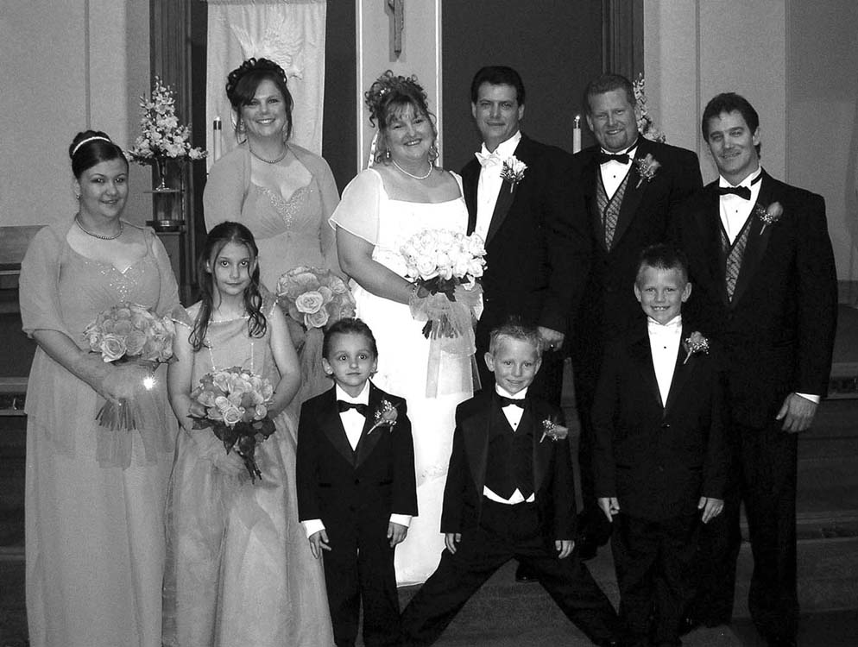

June, 2005 – Kyle as Ring Bearer in Aunt Pam's wedding

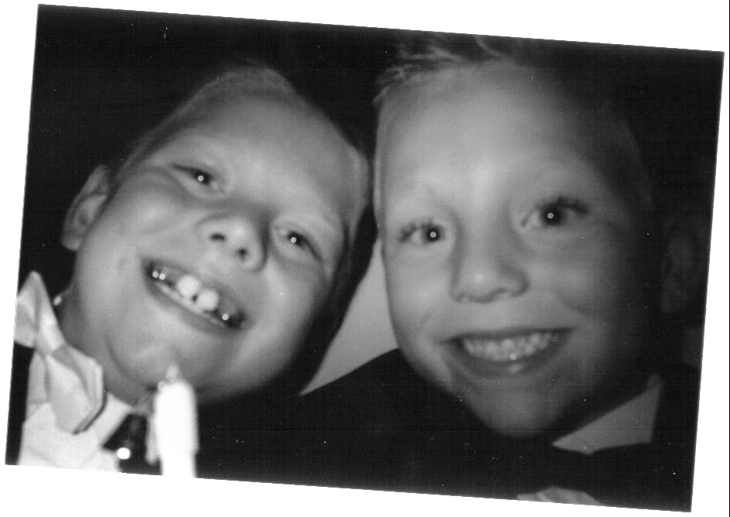

June, 2005 – Kyle and Bryan taking their own picture
at Aunt Pam's wedding.

Grandma Lois Potatoes
From the kitchen of Grandma Lois
In baking dish, place either with or without skins, potatoes quartered.
Place hunks of oleo over potatoes.
Sprinkle with salt and pepper.
Bake at 350 degrees for 45 to 50 minutes or until potatoes are done.
Keep turning potatoes to brown all over.

Toasted Orzo Pilaf
From the kitchen of cousin Merritt

2 tbsp. butter
½ medium onion, finely diced
½ tbsp. fresh garlic, minced
8 oz. orzo
½ cup vermouth
salt and pepper to taste
2 cups chicken or vegetable stock
½ small box frozen peas
½ cup freshly grated Parmesan cheese
pinch nutmeg

Melt butter in large pan over medium heat. Add onion and cook until lightly browned. Add garlic and cook another 30 seconds.
Stirring frequently, add the orzo and continue to cook until orzo is lightly browned, about 10 to 15 minutes.
Add vermouth and broth and bring to a boil. Reduce and simmer, stirring occasionally until liquid has been absorbed and orzo is tender, about 15 minutes.
Stir in Parmesan and nutmeg, season to taste. Remove from heat, stir in peas. Taste for seasoning and adjust as necessary.

Baked Beans
From the kitchen of Aunt Marie

4 cups dry navy beans
4 tbsp. brown sugar
4 tbsp. catsup
½ lb. bacon
3 tbsp. molasses
½ tsp. dry mustard
½ cup each diced, celery, onions, and green pepper.

Cover navy beans with water and soak overnight.
Boil beans slowly until tender. Mix brown sugar, mustard, molasses, catsup, salt and pepper, and some of the water beans boiled in (save water that beans boiled in after draining beans). Pour over beans.
In crock pot, layer beans, onions, celery and green pepper, bacon; repeat.
Cook on slow for 6 – 8 hours.

Roasted Green Beans
From the kitchen of cousin Merritt

2 lbs. fresh green beans, ends trimmed

2 tbsp. extra-virgin olive oil
coarse sea salt or kosher salt

Preheat oven to 500 F. Lightly oil a shallow roasting pan or cookie sheet.
Arrange green beans in a single uncrowded layer on pan. Drizzle oil over beans and roll until evenly covered.
Roast about 15 or 20 minutes until beans are well-browned, shaking the pan or turning frequently for even cooking. Keep oven light on and peek often; after 10 or 12 minutes, these can easily burn.
Transfer beans to a serving bowl and sprinkle with salt to taste. Serve immediately. Eat like French fries.

Cheesy Hash Browns
From the kitchen of Grandma Lois

2 lbs. hash browns, thawed
1 cup cream of chicken soup
8 oz. sour cream
½ cup chopped onion
1 stick melted oleo
8 oz. grated cheddar cheese
Salt and pepper to taste
Potato chips

Mix together and put in 9 x 13 baking pan with crushed potato chips across top.
Cover and bake at 350 degrees for I hour.

Canyon Ranch Stuffed Spuds
From the kitchen of cousin Merritt

2 small baking potatoes
(8 oz. each)
1 medium onion, finely chopped
¼ cup buttermilk
½ cup low-fat cottage cheese
3 tbsp. freshly grated Parmesan cheese
2 tbsp. chopped chives or scallion tops

Pierce potatoes with a fork; bake for 50 minutes at 400 degrees.
Cut a thin slice from the top of each potato. Remove the pulp from the potatoes, being careful not to tear the shells. Place the potato pulp in a mixing bowl and mash. Cover and set aside. Keep the shells warm.
Cook the onion in a medium skillet, covered, over very low heat until soft. Stir occasionally and a little water if necessary to prevent scorching. Add the mashed potatoes, buttermilk, cottage cheese and Parmesan. Mix well. Heat through.
Stuff the potato mixture back into the warm shells. The mixture will be heaped way over the top. To serve, sprinkle the top of each stuffed spud with one tablespoon of chopped chives or scallion tops.
If you have prepared the potatoes in advance, reheat them in a 350 F oven for about 15 minutes, or until hot, before adding the chopped chives and scallions.

Cornbread and Andouille Dressing
From the kitchen of cousin Vaughan

2 boxes Jiffy Corn Muffin Mix
2 tsp. unsalted butter
¾ lb. andouille sausage, casing removed and crumbled
1½ cups chopped yellow onions
1 cup chopped celery
1 cup chopped green bell peppers
1 tablespoon minced garlic
1 tsp. salt
½ tsp. freshly ground black pepper
3 slices white or whole wheat bread, torn into ½ inch pieces
½ cup chopped green onions
⅓ cup chopped fresh parsley
2 tsp. chopped fresh thyme
⅛ tsp. cayenne pepper
2 large eggs, beaten
1 to 2 cups chicken stock, as needed

The day before: Make the cornbread according to the directions on the box.
The day of: Preheat the oven to 350 degrees F. Generously butter a 13 by 9-inch baking dish and set aside.
In a large skillet, cook the sausage until brown and the fat is rendered, about 10 to 15 minutes. Add onions, celery, bell peppers, and garlic, and cook for 2 minutes. Remove from the heat and transfer to a large bowl to cool.
With your fingers, crumble the day-old cornbread into the bowl, add bread, the green onions, parsley, and thyme, and mix well with your hands. Add the salt, pepper, cayenne, and eggs, and mix well with your hands. Add enough broth, ½ cup at a time, to moisten the dressing, being careful not to make it mushy.
Transfer to the prepared dish and cover with aluminum foil. Bake until heated through, about 25 minutes. Uncover and bake until golden brown, about 15 minutes.

Fresh Tomato Sauce with Pasta
From the kitchen of Mary Condon, family friend

¼ cup finely chopped onion
2 cloves garlic, minced
1 tbsp. olive oil, margarine, or butter
4 cups peeled, seeded and chopped ripe fresh tomatoes (about 3 lbs) *
½ tsp. salt
¼ tsp. pepper
¼ cup sliced pitted ripe olives
¼ cup snipped fresh basil or 2 tsp. dried basil, crumbled
6 oz. dried capellini or spaghetti
Freshly shredded Parmesan cheese

*If tomatoes are especially juicy, place the chopped pieces in a strainer or colander set over a bowl. Let drain 10 to 15 min. to remove excess juices that can thin sauce.
Cook onion and garlic in hot oil, margarine or butter until onion is tender but not brown. Stir in 2 cups of the tomatoes, salt and pepper. Bring to boiling; reduce heat. Simmer, uncovered, for 15 min., stirring occasionally. Stir in remaining chopped tomatoes, ripe olives, and basil. Heat through. Meanwhile, cook capellini according to package directions. Drain. Serve tomato sauce over capellini. Sprinkle with cheese. Makes 6 side-dish servings.

Macaroni and Cheese
From the kitchen of Grandma Lois

1 (8 oz.) block of sharp cheddar cheese
1 box large shell pasta

½ cup milk
Oleo
Nature's Blend seasoning

Boil pasta as directed.
Grate cheese.
Drain pasta, add layer to baking dish, dot with oleo, sprinkle layer of cheese, and season. Add another layer of pasta and repeat, add milk.
Bake at 350 degrees for 40 – 45 minutes until golden brown.

Roasted Asparagus
From the kitchen of cousin Vaughan

Handful of asparagus
per person
Olive oil
Lemon wedge
Coarse salt

Preheat broiler.
Break stalks of asparagus at their natural snap point. Rinse and pat dry. Spread on baking sheet in single layer. Drizzle very lightly with olive oil, shake pan to coat.
Broil about 8 minutes, shaking pan occasionally so spears roast evenly. Squeeze lemon over spears and lightly dust with salt before serving.

Kyle & Bryan's Dad's Garlic Bread
From the kitchen of Craig

4 oz. soft butter
2 tbsp. chopped parsley
1 or 2 crushed garlic cloves
Dash of salt & pepper
1 whole loaf French bread

Make a deep cut along the whole length of a French loaf (don't cut it right through). Mix together the butter, chopped parsley, garlic and salt and pepper. Spread mixture along the cut and heat bread in oven at 400 degrees for about 5 minutes. Cut loaf into small slices or chunks. Serve hot!
Add mozzarella cheese if desired.

Pies and Cakes

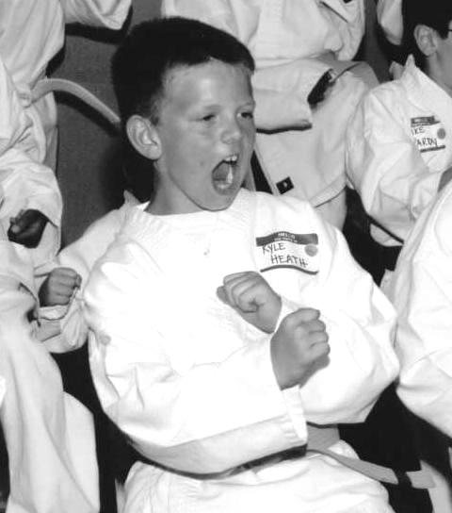

2005 – Kyle at his Kids Kicking Cancer Belting Ceremony
Beth captioned this photo "Kyle Kicking Cancer" – perfect!

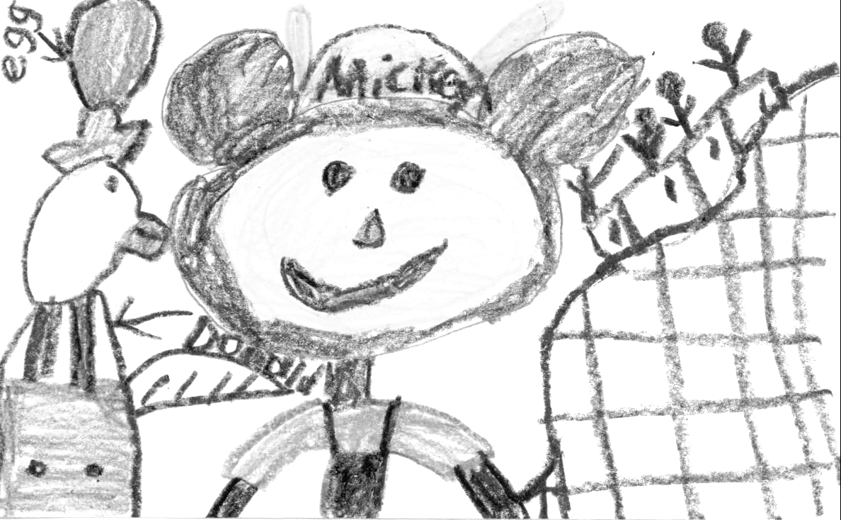

October, 2003 – Kyle's artwork of Mickey Mouse
and Walt Disney World

Pie Crust
From the kitchen of Grandma Lois

2 cups sifted flour
1 tsp. salt
¾ cup Crisco
½ cup water

With pastry blender, mix flour, salt and Crisco together. Slowly add water until all mixed together.
Hint – do not handle dough too much – it makes it tough.

Blueberry Pie
From the kitchen of Grandma Lois

1 cup sugar
5 tbsp. four
Dash of salt
1 tbsp. white vinegar
1 package frozen blueberries or 1 quart fresh blueberries

Mix all together.
Add to pie pan over bottom crust, dot with butter.
Cover with top crust. Cut slits.
Bake at 425 degrees for 10 minutes. Reduce heat to 350 degrees and bake 1 hour or until blueberries start to bubble.

Strawberry Pie
From the kitchen of Grandma Lois

1 quart strawberries, sliced
¾ cup sugar
2 tbsp. corn starch
1½ cups cold water
1 (3 oz.) box strawberry
Jell-O
1 tub Cool Whip

Mix sugar, corn starch and cold water, cook at medium heat to boil. Continue for 2 minutes, mixture will be thick and clear. Add package of Jell-O, stir to dissolve.
Add berries to cooked pie shell; pour mixture over berries in pie shell. Chill 2 hrs, add Cool Whip over top.

Buttercream Frosting
From the kitchen of Grandma Lois

2½ tbsp. flour
½ cup milk

½ cup sugar
¼ cup Crisco
½ cup oleo, softened
1 tsp. vanilla

Make paste of flour and milk, then bring to boil and then cool.
Beat sugar and Crisco, add oleo, slowly add sugar and beat well. Add vanilla, beat some more. Add flour mixture and continue beating until sugar is dissolved.
Double recipe for layer cake.

White Chocolate Cranberry Loaves
From the kitchen of cousin Merritt

1 (18¼ oz.) box white cake mix
¾ cup unbleached flour
1 tsp. orange peel
1 cup *fresh* cranberries (easy to find in December)
1 large egg
2 large egg whites
¾ cup water
½ cup orange juice
2 tbsp. unsweetened applesauce
1 cup white chocolate chips

Preheat oven to 350F.
Prepare 2 bread-size loaf pans, 5 mini-loaf pans, or 1 large and 3 minis with cooking spray. Mix cake mix, flour and orange peel. Add egg, egg whites, water, orange juice and applesauce. Fold in cranberries and white chocolate chips. Spread batter evenly between the two pans.
Bake for 45 minutes or until a toothpick inserted in the middle comes out clean.

The Ice Cream Pie
From the kitchen of Grandma Lois

⅓ cup peanut butter
⅓ cup Karo syrup
2 cups Rice Krispies
½ gallon softened ice cream (any flavor)

Grease an 8" or 9" pie plate with butter.
Mix together: ⅓ cup peanut butter and ⅓ cup of light Karo syrup
Add to 2 cups Rice Krispies
Put in pie plate and pat down on the bottom and sides with a piece of wax paper (the mixture is sticky)
Add a softened half gallon of your favorite ice cream (or as much ice cream as you desire)
Cover with foil and put in freezer till firm
Cut and serve

Boston Cream Pie
From the kitchen of Grandma Connie
1 yellow cake mix – prepare according to directions on cake mix - use 2 – 9 inch layer cake pans. After cake cools, slice each layer in half so you have four layers to make two cakes.
Cream filling:
Slowly warm 3 cups of milk in saucepan over stove. When milk is warm, add

3 egg yolks
¾ cup sugar
½ tsp. salt
1 tsp. vanilla

Add 2 – 3 tbsp. corn starch to consistency of pudding.
After filling has cooled, spread between two layers on each cake.
Top each cake with Sanders Hot Fudge and spread whipping cream over hot fudge topping. If desired, add chocolate sprinkles on top.

Crazy Chocolate Cake
From the kitchen of cousin Merritt

1½ cups sifted flour
3 tbsp. unsweetened cocoa
1 tsp. baking soda
¾ cup sugar
½ tsp. salt
6 tbsp. vegetable oil
1 tbsp. vinegar
1 tsp. vanilla
1 cup water

Sift dry ingredients into 8-inch ungreased cake pan; mix with a fork. Form 3 wells in flour. Into one pour the oil, into another pour the vinegar, and into the last the vanilla. Pour cold water over all and stir with a fork until well mixed. Bake at 350 degrees F for 30 minutes.
Fun to make with kids; limited clean-up required.

Stone Pie
From the kitchen of cousin Merritt

¼ cup butter
½ cup sugar
1 egg
1 not-so-very-leveled cup flour
pinch salt

1 tsp. baking powder
Sliced stone fruit (any combination of nectarines, peaches, plums, apricots, etc.)
2 tbsp. sugar
¼ – ½ tsp. cinnamon

Preheat oven to 350 degrees F.
Cream butter, add ½ cup sugar. Beat in egg. Mix in flour, baking powder and salt.
Pat into ungreased round pie pan. Arrange sliced fruit on top, as much as necessary to cover dough.
Mix 2 tbsp. sugar and cinnamon, sprinkle over fruit.
Bake at 350 degrees F for 25 – 30 minutes or until golden.

Apple Sheet “Pie”
From the kitchen of cousin Merritt

2½ cups flour
1 tbsp. sugar
1½ tsp. salt
1 cup Crisco
1 egg, separated
milk
1½ cups corn flakes, crushed
sugar and cinnamon (see below)
raisins

Make crust by mixing flour, sugar, salt in large bowl. Cut Crisco into this mixture till pea-size. Stir together egg yolk and enough milk to make ⅔ cup and blend into flour/Crisco mixture (like pie crust). Let crust rest in refrigerator while you prepare apples.
Peel, core and slice 3 lbs. apples (I like Granny Smith but you can use any mixture).
Divide dough in half, roll out one half to 15½” x 10” and fit onto cookie sheet. Cover with crushed corn flakes.
Mix 1 cup sugar with 1 tsp. cinnamon and toss with apples. Heap onto bottom crust. Sprinkle on raisins (if desired). Roll out remaining crust and cover, sealing edges.
Beat egg white till foamy and spread on top crust.
Bake at 400 degrees F for 1 hour.
Stir together 1 cup confectioner’s sugar with enough milk to make smooth icing and drizzle over cooled cake.

Zucchini Apple Cake
From the kitchen of cousin Merritt

2½ cups flour
2 cups sugar
1½ tsp. cinnamon
1 tsp. salt
½ tsp. baking powder
½ tsp. baking soda
¾ cup applesauce
¼ cup vegetable oil
2 eggs
4 egg whites
2 cups shredded zucchini
¾ cups California raisins (optional)

Preheat oven to 350. In a large mixing bowl, combine flour, sugar, cinnamon, salt, baking soda and baking powder. Make a well in the center. Set aside. Whip egg whites to stiff peaks, set aside.
Combine applesauce, oil & whole eggs; add to dry ingredients and mix well. Add zucchini and raisins if using. Stir until just combined. Gently fold in egg whites. Do not overmix.
Pour into a nonstick or greased 13 x 9 in pan and bake at 35 to 40 minutes or until a toothpick inserted in the center comes out clean.
Cool slightly, sprinkle with a dusting of confectioner’s sugar, serve warm.

Cookies and
Other Confections

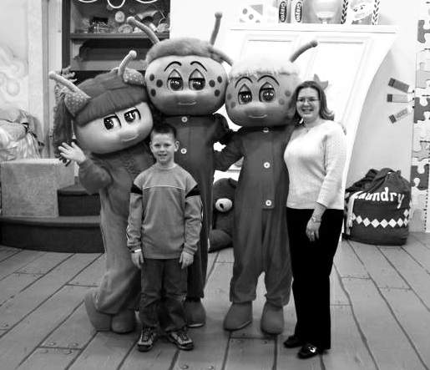

April, 2006 – Kyle and Sarah Umscheid (ACS)
with the Bed Bugs!

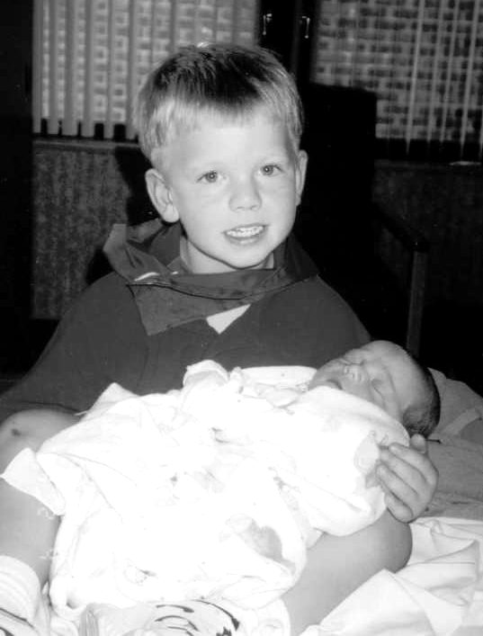

August, 2000 – Kyle wearing his "Big Brother" cape,
holding new baby brother, Bryan

Peanut Butter Cookies
From the kitchen of Grandma Lois

1 cup peanut butter
1 cup Crisco
1 cup sugar
1 cup brown sugar
2 eggs
2¼ cup flour
1 tsp. baking soda
1 tsp. vanilla
Pinch of salt

Beat together peanut butter, Crisco, sugar, brown sugar and eggs.
Mix flour, baking soda, pinch of salt.
Add to peanut butter mixture and mix together, add vanilla.
Bake at 425 degrees for 10 – 15 minutes.
Place tbsp. of dough on sheet and press with fork.

Chocolate Trixies
From the kitchen of Great Great Grandma Rita Heath

2 (1 oz.) squares unsweetened chocolate
½ cup oleo
1 cup sugar
1 egg

1 tsp. vanilla
½ cup flour
½ tsp. baking powder
¼ tsp. salt
1 cup pecans

Melt oleo and chocolate slowly. Cool slightly. Beat egg and sugar until creamy. Add chocolate mixture and vanilla.
Sift flour, baking powder and salt together. Add to chocolate mixture, add nuts.
Grease 8 inch square pan, pour in and spread. Bake at 360 degrees for 20 – 30 minutes.
Icing: melt 1 ounce square of chocolate and 2 tbsp. oleo, add 2 tbsp. warm water, stir in 1 cup powdered sugar.
Spread on cooled trixies and sprinkle with nuts.

Apple Crisp
From the kitchen of Grandma Lois
Slice 6 – 8 tart apples, arrange in shallow pan, dot with oleo.
Combine and work until crumbly:

½ cup flour
½ cup brown sugar
¼ cup softened oleo
1 tsp. cinnamon.

Sprinkle over apples.
Bake at 375 degrees about 30 minutes or until apples are tender.

Baked Caramel Apples
From Kyle

3 apples
6 caramels
2 tbsp. butter
Water

Cut 3 apples in half. Remove cores. Place in each apple half 1 dot of butter and 2 caramels. Butter a small baking dish. Add apples and ½ inch water. Bake about 15 minutes at 475 degrees. Cool 5 – 10 minutes before eating. Serves 6.

Rice Krispies Treats
From Kyle

6 cups of Rice Krispies cereal
3 tbsp. butter
1 package of regular marshmallows

Melt butter in large saucepan over low heat. Add marshmallows and stir until completely melted. Remove from heat. Add Rice Krispies cereal. Stir until well coated. Using buttered spatula or waxed paper, press evenly into a 13x9 pan coated with cooking spray. Cut into 2-inch squares when cool.
Makes 24 squares.

Microwave Chocolate Fondue
From Kyle

One 12 oz. package semisweet chocolate

2 tbsp. butter
¼ cup orange juice

Combine the chips, butter, and orange juice in a large microwave-safe bowl. Cover with wax paper and heat in the microwave on High for one min. Stir until the mixture is smooth. Heat for another min. if necessary or until any chunks are melted. Set in the center of a table, put out a plate of fresh strawberries or slices of orange, apple and banana and give everyone skewers or fondue forks for dipping the fruit into the chocolate. Makes 6 servings.

Chocolate Chip Chewies
From the kitchen of Grandma Lois
Cream:

⅔ cups Crisco shortening
2 cups brown sugar.

Beat:

2 eggs
1 tsp. vanilla

Add to Crisco mixture.
Sift:

2 cups flour
½ tsp. salt
1 tsp. baking powder

Mix with above.
Add

1 cup chopped nuts, if desired
1 6 oz. package chocolate chips

Grease 13 x 9 sheet pan. Spread across sheet pan.
Bake at 350 degrees for 30 minutes. When cooled, cut into squares.

Peaches Ice Cream Delight
From the kitchen of Aunt Barb Gillanders

Peaches (preferably Canadian)
Sugar
French vanilla ice cream
Cool Whip

Peel skin off peaches and cut peaches in ½" slices
Sprinkle sugar over cut peaches and stir, mixing sugar with peaches, making a sweet peach syrup.
Place two scoops of French vanilla ice cream in a bowl, place a helping of cut peaches over the top of the ice cream, and add a few spoonfuls of the peach syrup.
Add a spoonful of Cool Whip on top.

Club® Cracker Chocolate Toffee Nut Bars
From the kitchen of Debby Hunter, family friend

1 box Keebler Club® crackers
1 stick butter (not margarine)
½ cup brown sugar
1 cup milk chocolate chips
Desired amount of finely chopped walnuts or pecans

Preheat oven to 350 º. Line a 9 X 13” pan with foil and spray with non-stick cooking spray. Line the bottom of the foiled pan with a single layer of the crackers. In a saucepan, melt the butter. Add brown sugar and bring to a boil over medium high heat. Boil for 2 minutes. Pour mixture carefully over crackers. Bake in preheated oven for 5 minutes or until crackers “float.” Remove pan from oven and sprinkle the milk chocolate chips over the top. Spread the chocolate like frosting as it melts. Sprinkle finely chopped nuts evenly over the top. Press the nuts down gently into the chocolate.
**WHILE STILL WARM**, lift the entire sheet of uncut bars up and out of the pan by gripping foil. Put on top of a cutting board. Cut into squares or desired shape. **THEN** let cool. These stack very nicely when cool, and they make a pretty gift!

Strawberry Jam
From Kyle – this is his favorite*

2 quarts fresh strawberries
¼ cup lemon juice
2 oz. package dry pectin (Sure-jell)
1 cup corn syrup
4½ cups sugar

Wash, stem, and crush 2 quarts of strawberries. Mix with strawberries ¼ cup lemon juice and 2 oz. dry pectin. Stir mixture every 5 min for 30 minutes to completely dissolve pectin. Add 1 cup light corn syrup. Stir well. Gradually add 4½ cups of sugar. Stir well to dissolve completely. Refrigerate.
Makes 7 cups.

Zucchini Bread
From the kitchen of Grandma Lois
In large bowl, mix:

3 eggs, slightly beaten
1 cup vegetable or canola oil
2 cups sugar
3 cups grated zucchini
2 tsp. vanilla
8 oz. well-drained crushed pineapple

Mix together:

3 cups flour
1 tsp. baking soda
1 tsp. salt
1 tsp. baking powder
1 tsp. cinnamon

Mix dry ingredients to liquid mixture
Bake in greased loaf pans at 350 degrees for 1 hour or until toothpick comes out clean.
Makes 2 loaves.

Chocolate-Syrup-Spiced Root Beer Float
From Kyle

2 tbsp. chocolate syrup
1½ cups root beer
2 scoops vanilla ice cream

Pour 2 tbsp. of chocolate syrup into a glass. Add 1½ cups of root beer (or enough so the glass is ⅔ full) and stir the syrup and soda together to create a foamy head. Add two scoops of vanilla ice cream and garnish with sprinkles or drizzle chocolate syrup.
Makes one serving.

Peach Cobbler
From the kitchen of cousin Vaughan
Sauce

⅔ – 1 cup sugar
1 tbsp. cornstarch
1 cup boiling water
½ tbsp. butter
½ tsp. cinnamon
3+ cups fruit with juice

Shortcake dough

1 cup flour
1 tbsp. sugar
1½ tsp. baking powder
½ tsp. salt
3 tbsp. shortening
½ cup milk

Boil sugar, cornstarch, and water 1 minute, stirring. Add fruit and juice. Stir carefully. Pour into greased baking dish. Dot with butter, cinnamon and shortcake dough.
Bake at 400 degrees F for 30 minutes, and 10 or 15 more minutes at 350 degrees F until golden and bubbly.
Also excellent with other seasonal fruit: blueberries; strawberries/rhubarb, apples…

Worms in Dirt
From the kitchen of cousin Merritt

½ cup softened butter
1 cup cream cheese
½ to 1 cup powdered sugar
3½ cups milk
2 boxes vanilla pudding (or one 8-serving box)
12 oz. tub Cool whip
1 7” flowerpot or plastic pail
20 oz. package Oreos or chocolate wafers, crushed
Silk or plastic flowers
1 package Gummi worms

Mix butter, cream cheese and sugar. Mix milk, pudding and Cool Whip. Combine with butter mixture.
Layer cookie crumbs and gooey mix – don’t forget the worms! Plant flowers on top. Use Nilla Wafers for “beach sand” look. Great for kids’ parties.

Tropical Banana Bread
From the kitchen of cousin Merritt
In one bowl, mix:

1¼ cup cake flour
½ tsp. baking soda
1 tsp. baking powder
¾ cup - 1 scant cup sugar (use less sugar if the bananas are overripe.)

In another bowl, mix:

2 – 3 very ripe mashed bananas (the riper, the better -- entirely brown is fine.)
½ cup butter or margarine
2 eggs, beaten
1 tsp. vanilla
1 jigger each rum and brandy

Blend with flour mixture; mix well. Bake in greased loaf pan at 350 degrees F for one hour or until it tests done.

Grandma Denise's Fruit Delight Jell-O
From the Kitchen of Grandma Denise

1 (3 oz.) box lemon Jell-O
1 (3 oz.) strawberry Jell-O
1½ cups boiling water
1 pint sour cream
2 (10 oz.) cartons frozen strawberries
1 (20 oz.) can crushed pineapple

In large bowl, dissolve both Jell-Os in boiling water. Add frozen berries and pineapple, with juice. Pour one half of mixture into
8 x 8 pan. Place in fridge to set. Stir sour cream and spread over Jell-O mixture. Add remaining unset Jell-O and refrigerate.
Serves 9.

Great Grandma Anna's
Chocolate Delight Dessert
From the Kitchen of Great Grandma Anna

1 cup flour
1 cup chopped walnuts
1 stick softened butter

Mix well with fork. Press into bottom of 9 x 13 pan. Bake carefully at 350 for approx. 20 minutes or until light brown. Set aside to cool.

8 oz. softened cream cheese
1½ cups confectioner's sugar
1½ cups thawed Cool Whip

Blend well with electric mixer and spread in pan over cooled crust.

2 small boxes chocolate instant pudding
2¾ cup cold milk

Blend with electric mixer and spread over second layer.
Top layer - spread remaining Cool Whip over pudding mixture. Optional - sprinkle with chopped nuts or chocolate shavings
Note - purchase 12 or 16 oz. Cool Whip.

Beth's "Big Dipper" Bars
From the kitchen of Kyle’s mom, Beth

Crust:

1½ cups flour
½ tsp. baking powder
⅔ cup butter
2 eggs, slightly beaten
⅔ cup brown sugar
½ tsp. salt
¼ tsp. soda
1 tsp. vanilla

Filling:

¼ cup butter
1¼ cup powdered sugar
2¼ cup creamy or chunky peanut butter

Mix crust ingredients together, pat in 9x13 inch pan. Add mixed filling ingredients, put over top of crust. Bake at 350 degrees for 12 to 15 minutes.
Take out, add chocolate chips to bars. Put back in oven 2 to 3 minutes.

Aunt Rose’s Brownies
From the collection of Uncle Mike Collins

2 squares bittersweet chocolate
½ cup butter
1 cup sugar
2 eggs
1 tsp. vanilla
¾ cup flour
½ tsp. baking powder
½ tsp. salt

Preheat oven to 350 degrees.
Melt chocolate and butter in a double-boiler. Add sugar and eggs; beat together thoroughly. Add vanilla.
Sift flour, baking powder and salt together. Add to chocolate mixture and stir thoroughly.
Grease and flour a 9 x 9 or 8 x 8 pan, and pour in batter. Bake for 25 to 30 minutes.
When cool, cut into squares.

Banana, Cherry,
and White Chocolate Cupcakes
From the kitchen of cousin Merritt

½ cup unsalted butter
¾ cup sugar
1 tsp. vanilla extract
3 ripe bananas
4 tbsp. sour cream
2 large eggs
1 tsp. baking soda

½ tsp.baking powder
2 cups all-purpose flour
3 tbsp. dried cherries, chopped
2 oz. white chocolate, chopped, or chips
12-cup muffin pan with paper baking cups

Preheat the oven to 350 degrees.
Melt the butter in a saucepan, then, off the heat, add the sugar, vanilla, and soft bananas, mashing them with a fork in the pan.
Stir in the sour cream and the eggs and – still using your fork or a wooden spoon if you prefer – beat to mix. Add the baking soda and the baking powder, and stir in as well, then finally stir in the flour, cherries, and chocolate.
When the mixture's just blended, divide among the 12 muffin cups and cook for 20 minutes or until golden and springy on top.
Remove the cupcakes in their paper cups to a wire rack and leave till cool.
Makes 12.

Index of Recipes
Appetizers, Dips and Snacks 3
Artichoke Dip 6
Bread Dip in the Round 5
Chili Cheese Dip 6
Dill Dip 7
Garlic and Feta Cheese Dip 5
Grandma Denise's Shrimp Dip 5
Kyle's Trail Mix 7
Maple Chicken Drummies 8
Peanut Ginger Chicken Lettuce Wraps 7
Sausage Cheese Balls 6
Crabmeat and Shrimp Appetizer 8
Soups, Salads and Sandwiches 9
BBQ Beef Sandwiches 15
Broccoli Salad 12
Caramel Apple Salad 14
French Onion Soup 13
Great Grandma Brady's Beer Bread 13
Lentil, Vegetable and Barley Soup 12
Low Fat Asian-Style Slaw 16
Napa Cabbage Salad 15
Oriental Cole Slaw 18
Pasta Salad 14
Potato Salad 14
Salad with Spicy Peanut Sauce 17
Strawberry Pretzel Salad 16
Tuna Pasta Salad 18
Vinaigrette 17
Winter Squash Soup w/Gruyère Croutons 11
Breakfasts and Brunches 19
Breakfast Burritos 21
Cinnamon Muffins 23
Craig's French Toast 26
Fruit & Nut Breakfast Bites 21
German Puffed Pancake 23
Granola 24
Overnight “Christmas” Breakfast Casserole 26
Pancakes 22
Quiche 25
Sour Cream(less) Coffee Cake 25
Ziploc Omelets 22
Main Dishes 27
Beef and Napa Cabbage Stir-Fry 37
Beef Stew 33
Best Grilled Chicken Breasts 41
Chicken Broccoli Twist 33
Chicken or Turkey Lasagne 35
Chicken Piccata 34
Chicken Rice Roger 39
Chili 31
City Chicken Legs 44
Classic Beef Stroganoff 31
Coconut Chicken 43
Crock-pot Lemon Garlic Chicken 30
Easy Lemon Pork Chops 38
Goolash 36
Greyhound Loaf 44
Hot Chicken Salad 35
Kyle & Bryan's Mom's Lasagna 42
Meatballs and Gravy 30
Meatballs 40
Meatloaf 36
Pan-Fried Turkey, Chicken or Ham Sandwich 36
Parmesan Crusted Chicken 32
Pizza 37
Prime Rib of Beef 32
Shrimp Scampi 29
Spaghetti Sauce 29
Stuffed Pasta Shells 34
Stuffed Peppers 39
Tater Tot Casserole 40
Tomato-Basil Pasta 38
Tuna Casserole 40
White Chili 41
Side Dishes 45
Baked Beans 48
Canyon Ranch Stuffed Spuds 49
Cheesy Hash Browns 49
Cornbread and Andouille Dressing 50
Fresh Tomato Sauce with Pasta 51
Grandma Lois Potatoes 47
Kyle & Bryan's Dad's Garlic Bread 52
Macaroni and Cheese 51
Roasted Asparagus 52
Roasted Green Beans 48
Toasted Orzo Pilaf 47
Pies and Cakes 53
Apple Sheet “Pie” 59
Blueberry Pie 55
Boston Cream Pie 57
Buttercream Frosting 56
Crazy Chocolate Cake 58
Pie Crust 55
Stone Pie 58
Strawberry Pie 55
The Ice Cream Pie 57
White Chocolate Cranberry Loaves 56
Zucchini Apple Cake 60
Cookies and Other Confections 61
Apple Crisp 64
Aunt Rose’s Brownies 71
Baked Caramel Apples 64
Banana, Cherry, and White Chocolate Cupcakes 72
Beth's "Big Dipper" Bars 71
Chocolate Chip Chewies 65
Chocolate Trixies 63
Chocolate-Syrup-Spiced Root Beer Float 68
Club® Cracker Chocolate Toffee Nut Bars 66
Grandma Denise's Fruit Delight Jell-O 70
Great Grandma Anna's Chocolate Delight Dessert 70
Microwave Chocolate Fondue 65
Peach Cobbler 68
Peaches Ice Cream Delight 66
Peanut Butter Cookies 63
Rice Krispies Treats 64
Strawberry Jam 67
Tropical Banana Bread 69
Worms in Dirt 69
Zucchini Bread 67

Kyle's Favorite Things
4/15/06

1. Color: Blue and Red
2. Food: French Fries
3. Holiday: Christmas
4. Pet: Monkey
5. Toy: PS2
6. Place to Go on Vacation:
Walt Disney World/Give Kids the World
7. Video Game: Dance Dance Revolution
and Narnia
8. TV Show: Drake & Josh
9. Movie: Harry Potter & the Goblet of Fire
10. Music Group: Green Day
11. Music CD: Montgomery Gentry
12. Song: Holiday by Green Day
13. Sport: Soccer
14. Recipe in this Book: Pizza
15. About School: Lunch and Recess
16. School Subject: Science
17. About Camp: Hot-air balloon rides
18. About The Relay: Games

Thanks for the Recipes!

Kyle Heath
Beth Heath
Craig Heath
Lois Heath
Connie Heath
Pamela Brown
Scott Brown
Cathy Trombley
Sarah Umscheid
Grace Genova
Mary Condon
Laura Collins
The late Uncle
Mike Collins
Suzanne Galer
Deanna Galer
The late Great
Grandma Brady
The late Grandma
Denise Thompson
The late Great
Grandma Anna
Debby Hunter
Barb Gillanders
The late Great-Great Grandma Rita Heath
Sandy Petropoulos
Merritt Collins
Vaughan Scott
Royal Oak Woman’s Club

Layout by Merritt Scott Collins
interim communications services
m@924.org

For more information:

Relay For Life of Chesterfield Township
August 5–6, 2006
L'Anse Creuse Middle School–East
Chesterfield, Michigan
(30300 Hickey Road, west off Gratiot, north of 24 Mile Road)
Event Chair: Beth Heath beth@hopeinchesterfield.org
www.hopeinchesterfield.org

Cruisin' With Kyle
Team Captain: Pamela Brown pamela.d.brown@us.pwc.com

Thanks, everyone,

for your support!

